**Sample Works**

Sample Image-1

Sample Image -2

Sample image-3

Sample image-4

Sample image-5

Sample image-6

Sample Image-7

Sample Image-8

Sample Image-9

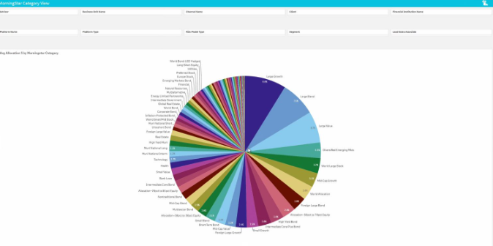

Sample Image-10

